Cybersecurity Investigation and Threat Analysis Unit (CITA)
Threat Hunting Investigation Process
Standard Operating Procedure (SOP)
SOP# | Description | Effective | Last Edit | Cancelled
CITA-XXX | Cybersecurity Operations and Response Center – Threat Hunting and Analysis | mm/dd/2025 | 12/14/2025
Approved by | Brian Jones, Chief CITA

1. Purpose
This Standard Operating Procedure (SOP) defines the Threat Hunting and Analysis framework used by the Cybersecurity Investigation and Threat Analysis Unit (CITA). The framework establishes a consistent, NIST-aligned approach for proactively identifying, investigating, analyzing, and reporting cybersecurity threats and incidents affecting Cyber Support Agency (CSA) information systems and assets.
This SOP applies to all threat hunting and investigative activities conducted within the Cybersecurity Operations and Response Center (CORe).

2. Document Control
It is the responsibility of all personnel to ensure they are using the most current version of this SOP. Questions regarding this document should be directed to the CITA Unit Chief.
This SOP supersedes all prior CITA threat hunting and analysis procedures unless explicitly retained by written exception.

3. References
- NIST SP 800-61 Rev. 2, Computer Security Incident Handling Guide
- NIST SP 800-86, Guide to Integrating Forensic Techniques into Incident Response
- NIST SP 800-30 Rev. 1, Guide for Conducting Risk Assessments

4. Introduction
The Cybersecurity Operations and Response Center (CORe) serves as the first line of defense for detecting, investigating, and responding to cybersecurity incidents across CSA infrastructure. CORe analysts defend CSA information assets against intrusions, unauthorized activity, vulnerabilities, and violations of acceptable use, policy, and procedure.
Advanced Persistent Threats (APTs) pose a significant risk to the confidentiality, integrity, and availability of government information systems. Nation-state actors, in particular, leverage substantial resources to develop and deploy sophisticated capabilities designed to exfiltrate sensitive information and disrupt government operations. These threats often evade traditional perimeter defenses and persist within enterprise environments for extended periods.
To counter these threats, the CORe employs a defense-in-depth strategy that combines automated detection, continuous monitoring, and proactive threat hunting. Threat hunting enables analysts to identify adversary activity that may not trigger automated alerts by examining logs, telemetry, and behavioral anomalies across networks, systems, applications, and data stores.

5. Overview of the Threat Hunting Investigation Process
Threat hunting within the CORe integrates with established incident response processes and leverages both automated alerts and analyst-driven discovery. Alerts may originate from security tools such as Splunk, as well as from reports submitted by Joint Security Operations Center (JSOC), CSA system owners, and the CSA Service Desk.
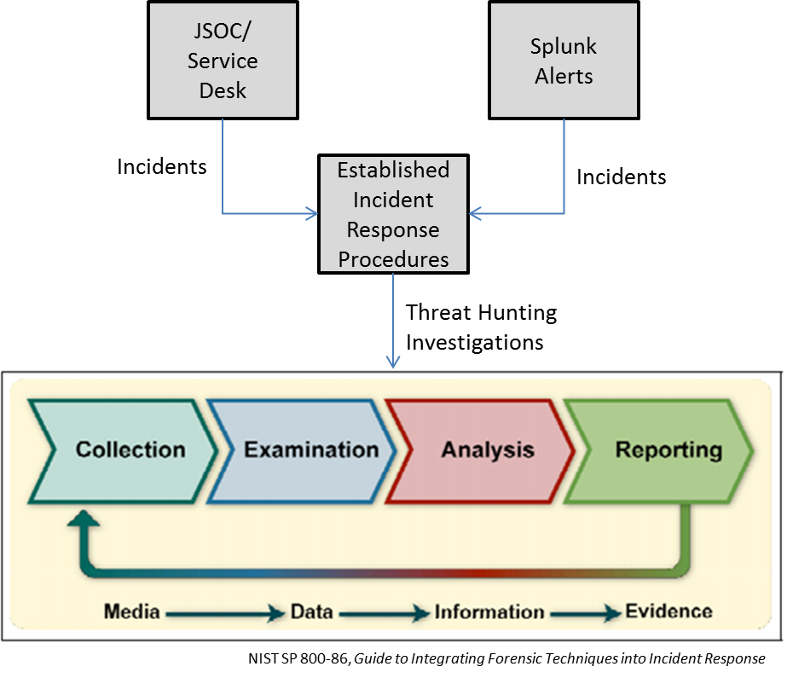
Figure 1: Threat Hunting Investigation Process

Threat hunting is a proactive, hypothesis-driven activity conducted continuously across all shifts. The CORe maintains a 24x7 threat hunting capability supported by persistent access to investigative tools and data sources.
This SOP adopts the four-phase forensic investigation model defined in NIST SP 800-86:
- Collection
- Examination
- Analysis
- Reporting
These phases provide a structured and repeatable framework for conducting threat hunting investigations within the CORe.

6. Collection
During the Collection phase, CORe analysts identify, acquire, label, and preserve data relevant to the investigation. Collection activities must be conducted promptly to prevent data loss, contamination, or alteration.
6.1 Containment Coordination
CORe analysts are responsible for determining appropriate containment actions using established CORe decision processes. In some cases, CSA personnel may seek to reimage systems before forensic data can be collected. Analysts must assess the situation and provide clear direction to ensure investigative integrity.
Until containment decisions are finalized, CORe analysts shall direct CSA personnel to leave impacted systems intact and perform reimaging only when explicitly authorized.
6.2 Collection Guidance to CSA Personnel
Instructions provided to CSA personnel may include, but are not limited to:
- Restricting access to impacted systems to authorized personnel only
- Documenting all users with access to affected systems
- Disconnecting network cables when instructed
- Disabling wireless adapters or powering down wireless access points as directed
6.3 Initial Incident Information
To support effective investigation, analysts should gather the following information when incidents are reported:
Victim Information
- User name, location, contact information, supervisor
- Description of observed activity or incident
System and Network Information
- Hostname, IP addresses, MAC addresses
- Wired and wireless network details
- Subnet, gateway, switch, and port information
Timeline
- Events preceding, during, and following the incident
Evidence of Malicious Activity
- Logs, files, processes, configurations, or protocol misuse
6.4 Indicators of Compromise (IoC) Collection
Table 1 identifies indicators that may signal malicious activity, including APT presence. Measurements that significantly exceed established baselines warrant further examination.
Table 1: Indicators of Compromise (IoC) Analysis
IoC | Tool | Baseline¹ | Measurement²
Unusual outbound traffic | Splunk | TBD | TBD
Privileged user account activity anomalies | Splunk | TBD | TBD
Geolocation anomalies | Splunk | TBD | TBD
Login-related issues | Splunk | TBD | TBD
Increased in database read activity | Splunk | TBD | TBD
Unusual HTML response size | Splunk | TBD | TBD
Numerous requests for the same file | Splunk | TBD | TBD
Application port mismatch | Splunk | TBD | TBD
System file and registry changes | Splunk | TBD | TBD
Strange DNS requests | Splunk | TBD | TBD
Data cached in suspicious locations | Splunk | TBD | TBD
Patching anomalies | Splunk | TBD | TBD
Bot-related web activity | Splunk | TBD | TBD
DDoS symptoms and activity | Splunk | TBD | TBD
4624 authentication events (An account was successfully logged on) from within systems on the network; look for odd patterns | Splunk | TBD | TBD
4688 events (A new process has been created) and related command line and PowerShell processes | Splunk | TBD | TBD
Long running transactions (>8 hours) | Splunk | TBD | TBD
DNS responses with high entropy (very random) domain names | Splunk | TBD | TBD
Unknown user agents observed | Splunk | TBD | TBD
SSL interactions with known malicious, self-signed sites | Splunk | TBD | TBD
Dynamic DNS queries to D-DNS providers | Splunk | TBD | TBD
Long DNS queries, DNS txt queries, excessive DNS failed queries | Splunk | TBD | TBD
Network protocols misuse, ie DNS packets used to exfiltrate data? | Splunk | TBD | TBD

Baseline values are established by CORe Splunk engineers through dashboards and reporting. Analysts compare current measurements against these baselines during investigations.
Note: While some baseline capabilities may be under development, establishing and refining these measurements remains an operational objective.
6.5 Documentation and Shift Continuity
All collection activities shall be documented in the Response Tracker (RT). Collection continues across shifts until complete. Outgoing analysts must provide a detailed handoff to incoming analysts during shift turnover.

7. Examination
During the Examination phase, analysts develop and test hypotheses regarding potential threats within the environment. Hypotheses are informed by collected data, threat intelligence, situational awareness, and analyst experience.
Threat hunting is inherently hypothesis-driven. Analysts adopt a security mindset by posing “what-if” questions to explain observed anomalies and determine whether adversary activity is present.
7.1 Hypothesis Examples
- If privileged account anomalies exist, could an adversary have compromised elevated credentials?
- If patching anomalies are observed, could systems have been intentionally downgraded to reintroduce vulnerabilities?
- If abnormal HTML response sizes occur, could data exfiltration be taking place?
- If unusual outbound traffic is detected, could command-and-control communications be established?
The following table provides guideline questions to be considered during the examination phase:
Table 2: Examination Questions
Examination Question | Tool, Technique, or Procedure | Reference
What evidence is there that the adversary is doing research? Social media? Phishing? | TBD | TBD
What evidence is there that an artifact (PDF file, Word file, etc.) was weaponized? | TBD | TBD
How was the weapon transmitted to the target environment? | TBD | TBD
What is the source address? Has it been anonymized? | TBD | TBD
Are there encrypted files that should not be encrypted? | TBD | TBD
Was the weapon triggered? What was its target? | TBD | TBD
What evidence is there of a back door or remote access trojan? | TBD | TBD
What evidence is there of suspicious activity of users with privileged accounts? | TBD | TBD
What evidence is there of credential escalation or unauthorized credential usage? | TBD | TBD
What evidence is there of lateral movement? | TBD | TBD
What evidence is there of the weapon beaconing signals as part of a command and control network? | TBD | TBD

7.2 Examination Considerations
Analysts examine evidence using available tools, techniques, and procedures, considering adversary tools, tactics, and procedures (TTPs) and known indicators of compromise.
(Examination table retained with TBD placeholders to reflect evolving toolsets.)
7.3 Documentation and Shift Continuity
All examination activities shall be documented in RT. Examination efforts continue across shifts with formal turnover until the phase is complete.

8. Analysis
During the Analysis phase, analysts determine the significance and impact of validated findings. Analysis synthesizes examination results to identify relationships among systems, users, events, and adversary activity.
Analysts assess:
- The nature and scope of the threat
- Impact to CSA operations, data, and mission
- Evidence of persistence, lateral movement, or exfiltration
Analysis must be methodical and defensible, supporting conclusions that can be clearly communicated to stakeholders, including CSA leadership and system owners.
8.1 Analysis Considerations
- Attribution indicators (e.g., IP ownership, infrastructure reuse)
- Threat actor classification (e.g., criminal, hacktivist, nation-state, insider)
- Weapon capability and sophistication
- Organizational impact and risk
8.2 Documentation and Shift Continuity
All analysis activities shall be documented in RT and transitioned across shifts until complete.

9. Reporting
The Reporting phase documents investigative findings and communicates results to stakeholders. Analysts shall clearly describe investigative actions, tools used, and rationale for conclusions.
Reports must include:
- Summary of findings
- Supporting evidence
- Assessment of uncertainty or alternative explanations
- Recommended follow-up actions and process improvements
All reports shall be entered into RT and summarized in weekly reporting. Analysts must be prepared to support follow-on inquiries from leadership.
9.1 Risk-Informed Reporting Elements
Final reports should incorporate the following elements aligned with NIST SP 800-30:
- Threat Event
- Threat Sources
- Capability
- Intent
- Targeting
- Relevance
- Likelihood
- Vulnerabilities and Predisposing Conditions
- Severity and Pervasiveness
- Likelihood of Successful Attack

End of Standard Operating Procedure

